ក្ដារចុចខ្មែរអង្គ

មាតិកា

Overview 2

Khmer Angkor Keyboard Layouts 2

Desktop Layout –Windows/macOS 2

Touch Layout –Android/iOS 3

Khmer Character Categories and Their Keystroke 4

Consonants 4

Dependent Vowels 5

Independent Vowels 5

Diacritics 5

Native Punctuations 6

Latin Punctuations 6

Currencies 6

Khmer Numerals 6

Divination Lore 6

Khmer Lunar Dates 7

Deprecated characters 7

Joiners and Spaces 8

Typing in Khmer 8

Silent Auto-correction 8

Subscript + Vowel 8

Subscript + ្រ [U+17D2] [U+179A] 8

Subscript + Consonant Shifter + Vowel 9

Consonant Shifter + Vowel 9

Vowel with Nikahit [U+17C6] 9

Vowel ោ [U+17C4] and Vowel ើ [U+17BE] 9

Visually Identical Subscript 9

Vowel Rotation 9

Beep / Constraints 10

Mistyped Characters 10

# សេចក្ដី​ផ្ដើម

ឯកសារ​នេះ​ត្រូវ​បាន​ដកស្រង់​និង​សម្រួល​មក​ពី​៣​ប្រភព៖ «របៀបវាយយូនីកូដខ្មែរ» «យូនីកូដស្តង់ដា កំណែ១០.០.០» និង អត្ថបទ​ស្រាវជ្រាវ​ដែល​ក្រុម​ការងារ​ឃីមែន​បាន​សរសេរនិង​ធ្វើ​បទ​បង្ហាញ​នៅ​សន្និសិទ្ធអាស៊ី​ស្ដី​ពី​ប្រព័ន្ធ​ព័ត៌មាន​នៅ​ឆ្នាំ​២០១៧​ក្រោម​ចំណង​ជើង​ថា «ភាព​ងាយ​រងគ្រោះ​ដោយការរែនឌើរក្នុង​ការប្រើប្រាស់យូនីកូដខ្មែរ»។ ការកែកុន​បន្ថែមធ្វើ​ឡើង​ដោយ​ក្រុមការងារឃីមែន។ ស្រទាប់​១​ត្រូវ​បាន​បន្ថែម​លើ​កម្មវិធី​សម្រាប់​ឌែសថប​និងឧបករណ៍​ថាច់​​ដើម្បី​ដាក់លេខ​ខ្មែរ​បុរាណ​ដែល​ប្រើ​សម្រាប់​ការ​ទស្សទាយ​និង​ការបរិច្ឆេទ​ចន្ទគតិ។

# Khmer Angkor Keyboard Layouts

## Desktop Layout –Windows/macOS

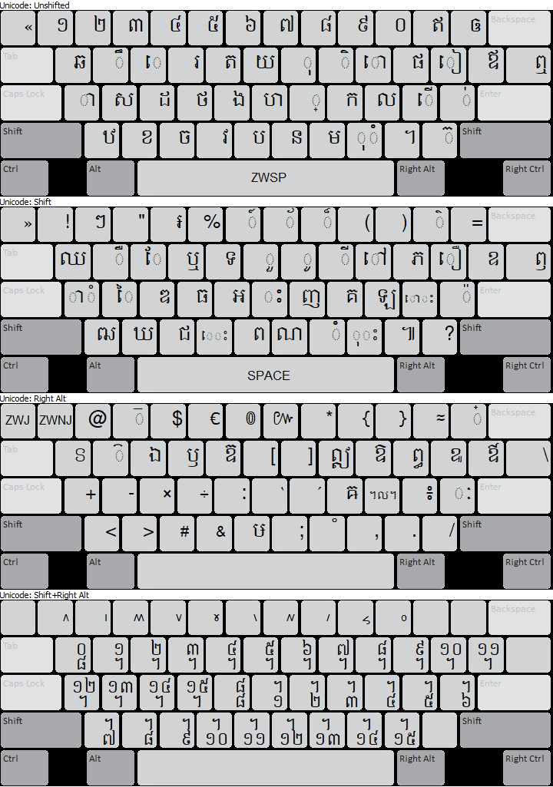



## Touch Layout –Android/iOS

There is no Shift key nor subscript sign in the touch layout to switch between layouts. Strange, right? Yes, maybe, but it is not easy to reach for the “Shift” key one-handedly. More keys are embedded in each key—press and hold for a second or so to see more available keys. For example, to get subscript “្រ”, “ឬ” or “ឫ”, press and hold on key “រ”. You may notice that on the Khmer Angkor keyboard for desktop, these four characters are on key R; which is why they are all packed into this one key hidden in the long press.

While using the touch keyboard, one has to be aware of the location of each key. This may take a while to get used to, but it would be easier, once passed the learning curve, than pressing Shift each time to get addition characters and pressing ្ each time to get a subscript.

Default layout

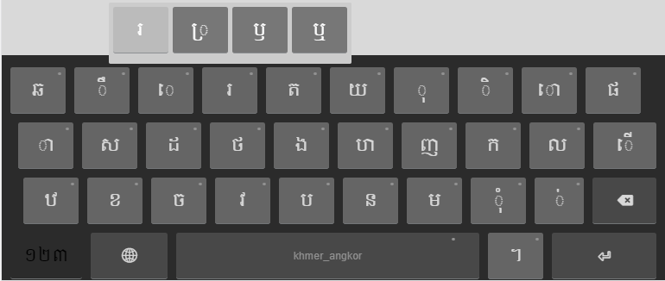

Numeric layout

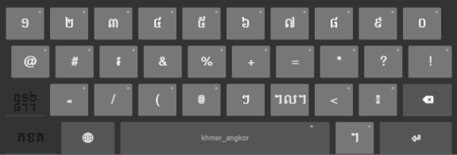

Divination Lore and Khmer Lunar Dates layout

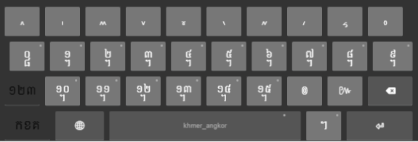

# Khmer Character Categories and Keystrokes for Desktop

## Consonants

|  |  |  |  |  |
| --- | --- | --- | --- | --- |
| **Consonant** | **Keystroke** |  | **Consonant** | **Keystroke** |
| ក [U+1780] | K | ថ [U+1790] | F |
| ខ [U+1781] | X | ទ [U+1791] | Shift T |
| គ [U+1782] | Shift K | ធ [U+1792] | Shift F |
| ឃ [U+1783] | Shift X | ន [U+1793] | N |
| ង [U+1784] | G | ប [U+1794] | B |
| ច [U+1785] | C | ផ [U+1795] | P |
| ឆ [U+1786] | Q | ព [U+1796] | Shift B |
| ជ [U+1787] | Shift C | ភ [U+1797] | Shift P |
| ឈ [U+1788] | Shift Q | ម [U+1798] | M |
| ញ [U+1789] | Shift J | យ [U+1799] | Y |
| ដ [U+178A] | D | រ [U+179A] | R |
| ឋ [U+178B] | Z | ល [U+179B] | L |
| ឌ [U+178C] | Shift D | វ [U+179C] | V |
| ឍ [U+178D] | Shift Z | ស [U+179F] | S |
| ណ [U+178E] | Shift N | ហ [U+17A0] | H |
| ត [U+178F] | T | ឡ [U+17A1] | L |
|  |  | អ [U+17A2] | Shift G |

## Dependent Vowels

|  |  |  |  |  |
| --- | --- | --- | --- | --- |
| **Dependent Vowel** | **Keystroke** |  | **Dependent Vowel** | **Keystroke** |
| ា [U+17B6] | A | ែ [U+17C2] | Shift E |
| ិ [U+17B7] | I | ៃ [U+17C3] | Shift S |
| ី [U+17B8] | Shift I | ោ [U+17C4] | O |
| ឹ [U+17B9] | W | ៅ [U+17C5] | Shift O |
| ឺ [U+17BA] | Shift W | ុំ [U+17BB][U+17C6] | , |
| ុ [U+17BB] | O | ំ [U+17C6] | Shift M |
| ូ [U+17BC] | Shift O | ាំ [U+17B6][U+17C6] | Shift A |
| ួ [U+17BD] | Shift Y | ះ [U+17C7] | Shift H |
| ើ [U+17BE] | ; | ុះ [U+17BB][U+17C7] | Shift , |
| ឿ [U+17BF] | Shift [ | េះ [U+17C1][U+17C7] | Shift V |
| ៀ [U+17C0] | [ | ោះ [U+17C4][U+17C7] | Shift ; |
| េ [U+17C1] | E | ៈ [U+17C8][1] | AltGr ’ |

## Independent Vowels

|  |  |  |  |  |
| --- | --- | --- | --- | --- |
| **Independent Vowel** | **Keystroke** |  | **Independent Vowel** | **Keystroke** |
| ឥ [U+17A5] | - | ឭ [U+17AD] | Shift \ |
| ឦ [U+17A6] | AltGr I | ឮ [U+17AE] | \ |
| ឧ [U+17A7] | Shift ] | ឯ [U+17AF] | AltGr E |
| ឩ [U+17A9] | AltGr [ | ឰ [U+17B0] | AltGr P |
| ឪ [U+17AA] | ] | ឱ [U+17B1] | AltGr O |
| ឫ [U+17AB] | AltGr R | ឲ [U+17B2] | = |
| ឬ [U+17AC] | Shift R | ឳ [U+17B3] | AltGr ] |

## Diacritics

|  |  |  |  |  |
| --- | --- | --- | --- | --- |
| **Diacritics** | **Keystroke** |  | **Diacritics** | **Keystroke** |
| ៉ [U+17C9] | Shift ’ | ៏ [U+17CF] | Shift 8 |
| ៊ [U+17CA] | / | ័ [U+17D0] | Shift 7 |
| ់ [U+17CB] | ’ | ៎ [U+17CE] | AltGr = |
| ៌ [U+17CC] | Shift - | ៓ [U+17D3] | AltGr M |
| ៍ [U+17CD] | Shift 6 | ្ [U+17D2] | J |

## Native Punctuations

|  |  |  |  |  |
| --- | --- | --- | --- | --- |
| **Native Punct.** | **Keystroke** |  | **Native Punct.** | **Keystroke** |
| ។ [U+17D4] | . | ៘ [U+17D8] | AltGr L |
| ៕ [U+17D5] | Shift . | ៙ [U+17D9] | AltGr 6 |
| ៖ [U+17D6] | AltGr ; | ៚ [U+17DA] | AltGr 7 |
| ៗ [U+17D7] | Shift 2 |  |  |

## Latin Punctuations

|  |  |  |  |  |
| --- | --- | --- | --- | --- |
| **Latin Punct.** | **Keystroke** |  | **Latin Punct.** | **Keystroke** |
| ! [U+0021] | Shift 1 | « [U+00AB] | ` |
| ? [U+003F] | Shift ? | » [U+00BB] | Shift ` |
| “ [U+0022] | Shift 3 | - [U+002D] | AltGr S |
| . [U+002E] | AltGr . | : [U+003A] | AltGr G |
| , [U+002C] | AltGr , | ‘ [U+2018] | AltGr H |
| ; [U+003B] | AltGr N | ’ [U+2019] | AltGr J |
| # [U+0023] | AltGr C |  | & [U+0026] | AltGr V |

## Currencies

|  |  |
| --- | --- |
| ៛ [U+17DB] | Shift 4 |

## Khmer Numerals

|  |  |  |  |  |
| --- | --- | --- | --- | --- |
| **Khmer Numeral** | **Keystroke** |  | **Khmer Numeral** | **Keystroke** |
| ១ [U+17E1] | 1 | ៦ [U+17E6] | 6 |
| ២ [U+17E2] | 2 | ៧ [U+17E7] | 7 |
| ៣ [U+17E3] | 3 | ៨ [U+17E8] | 8 |
| ៤ [U+17E4] | 4 | ៩ [U+17E9] | 9 |
| ៥ [U+17E5] | 5 | ០ [U+17E0] | 0 |

## Divination Lore

|  |  |  |  |  |
| --- | --- | --- | --- | --- |
| **Divination Lore** | **Keystroke** |  | **Divination Lore** | **Keystroke** |
| ៱ [U+17F1] | AltGr Shift 1 | ៶ [U+17F6] | AltGr Shift 6 |
| ៲ [U+17F2] | AltGr Shift 2 | ៷ [U+17F7] | AltGr Shift 7 |
| ៳ [U+17F3] | AltGr Shift 3 | ៸ [U+17F8] | AltGr Shift 8 |
| ៴ [U+17F4] | AltGr Shift 4 | ៹ [U+17F9] | AltGr Shift 9 |
| ៵ [U+17F5] | AltGr Shift 5 | ៰ [U+17F0] | AltGr Shift 0 |

## Khmer Lunar Dates

|  |  |  |  |  |
| --- | --- | --- | --- | --- |
| **Khmer Lunar Date** | **Keystroke** |  | **Khmer Lunar Date** | **Keystroke** |
| ᧠ [U+19E0] | AltGr Shift Q | ᧰ [U+19F0] | AltGr Shift G |
| ᧡ [U+19E1] | AltGr Shift W | ᧱ [U+19F1] | AltGr Shift H |
| ᧢ [U+19E2] | AltGr Shift E | ᧲ [U+19F2] | AltGr Shift J |
| ᧣ [U+19E3] | AltGr Shift R | ᧳ [U+19F3] | AltGr Shift K |
| ᧤ [U+19E4] | AltGr Shift T | ᧴ [U+19F4] | AltGr Shift L |
| ᧥ [U+19E5] | AltGr Shift Y | ᧵ [U+19F5] | AltGr Shift ; |
| ᧦ [U+19E6] | AltGr Shift U |  | ᧶ [U+19F6] | AltGr Shift ’ |
| ᧧ [U+19E7] | AltGr Shift I |  | ᧷ [U+19F7] | AltGr Shift Z |
| ᧨ [U+19E8] | AltGr Shift O |  | ᧸ [U+19F8] | AltGr Shift X |
| ᧩ [U+19E9] | AltGr Shift P |  | ᧹ [U+19F9] | AltGr Shift C |
| ᧪ [U+19EA] | AltGr Shift [ |  | ᧺ [U+19FA] | AltGr Shift V |
| ᧫ [U+19EB] | AltGr Shift ] |  | ᧻ [U+19FB] | AltGr Shift B |
| ᧬ [U+19EC] | AltGr Shift A |  | ᧼ [U+19FC] | AltGr Shift N |
| ᧭ [U+19ED] | AltGr Shift S |  | ᧽ [U+19FD] | AltGr Shift M |
| ᧮ [U+19EE] | AltGr Shift D |  | ᧾ [U+19FE] | AltGr Shift , |
| ᧯ [U+19EF] | AltGr Shift F |  | ᧿ [U+19FF] | AltGr Shift . |

## Deprecated characters

|  |  |
| --- | --- |
| **Deprecated Character** | **Keystroke** |
| ឝ [U+179D] | AltGr K |
| ឞ [U+179E] | AltGr B |
| ឨ [U+17A8] | AltGr T |
| ៜ [U+17DC] | AltGr Q |
| ៝ [U+17DD] | AltGr W |
| ៑[2] [U+17D1] | AltGr 3 |
| ៓ [U+17D3] | AltGr M |

## Joiners and Spaces

|  |  |
| --- | --- |
| **Key name** | **Keystroke** |
| Zero-width non-joiner [U+200C] | Ctrl + Alt + 1 |
| Zero-width joiner [U+200D] | Ctrl + Alt + ‘ |
| Zero-width space [U+200B] | Spacebar |
| White space [U+0020] | Shift + Spacebar |
| No break space [U+00A0] | Ctrl + Alt + Spacebar |

# Typing in Khmer

Khmer Angkor keyboard adopted the key arrangement from that of Khmer NiDA keyboard. More functionalities have been added to it to assist in typing (i.e. reduce inconsistency in character sequences). Regardless of how the user may type, a well-formed word will be produced. Please note that only issues identified are covered. For how to install the Khmer Angkor keyboard, please click [here](https://help.keyman.com/products/desktop/9.0/docs/start_download-install_keyboard.php) for the instructions.

You can simply use Khmer Angkor as you would for any NiDA based keyboard.

## Silent Auto-correction

There are eight cases of invisible typos that Khmer Angkor keyboard automatically corrects. They could not be detected with the naked eye; and the rendering engines may render them all the same on the screen. The auto-correction involves reordering and/or transducing of certain characters.

### Subscript + Vowel

When a subscript and a vowel occur together, the vowel has to come after the subscript. For instance, ខ្មែរ and ខែ្មរ look the same, but they are encoded differently.

* ខ្មែរ = ខ ្ម ែ រ (correct)
* ខែ្មរ = ខ ែ ្ម រ (incorrect)

Thanks to the context dependent rules, Khmer Angkor keyboard is able to output the second typing sequence the same as that of the first one.

### Subscript + ្រ [U+17D2] [U+179A]

According to the spelling rule, in a sequence of two subscript and one of which is ្រ [U+17D2] [U+179A], the ្រ [U+17D2] [U+179A] should come after another subscript.

* កញ្ជ្រឹល = ក ញ ្ជ ្រ ឹ ល (correct)
* កញ្រ្ជឹល = ក ញ ្រ ្ជ ឹ ល (incorrect)

As you can see the two-character sequences yield the same visual output on the screen. Once again, Khmer Angkor will be able to automatically swap the sequence of the second to the first; so that the output would be both looked and encoded correctly and consistently.

### Subscript + Consonant Shifter + Vowel

This is a case whereby the character sequence is vague in the Unicode Standard. Unicode Standard 4.0 and later have the consonant shifter come between the consonant and the subscript while Unicode Standard 3.0 has it after the subscript. Khmer Angkor agrees with the later and it is taken as the standard sequence. If one typed a consonant shifter before a subscript, the order would be switched silently.

ម ៉ ្យ ា ង ⇒ ម ្យ ៉ ា ង

### Consonant Shifter + Vowel

Consonant shifters should be typed before a vowel. (See the same in the section above)

### Vowel with Nikahit [U+17C6]

Nikahit is considered as a sign in the Unicode Standard. However its function is more like that of a vowel. It is usually combined with another vowel, i.e. ុ [U+17BB] ា [U+17B6], and it should always be typed after these vowels.

ក ំ ុ ⇒ ក ុ ំ  
 ក ំ ា ⇒ ក ា ំ

### Vowel ោ [U+17C4] and Vowel ើ [U+17BE]

These two vowels could be mistakenly typed by adding ា [U+17B6] and េ [U+17C1] respectively to េ [U+17C1]. Given this sequence, Khmer Angkor would transform them to ោ [U+17C4] and ើ [U+17BE], the correct vowel encodings.

### Visually Identical Subscript

Two subscripts look exactly the same, but they are encoded with different Unicode code points, ្ដ [U+17D2][U+178A] and ្ត [U+17D2][U+178F]. Since a spelling rule governs that the first should come after ណ [U+178E] and the later should come after ន [U+1793].

## Vowel Rotation

Since no two-vowel sequence is allowed, once one is typed after another, the vowel would switch to the one typed last. For example, if the current character is vowel ា [U+17B6], and then ែ [U+17C2] is typed, the final output would be ែ [U+17C2], not ា [U+17B6].

**NOTE**: The vowel rotation would not be triggered in the following cases:

* If the first vowel is េ [U+17C1] and the second is ី [U+17B8], then the switch would not happen, but the output would be ើ [U+17BE] instead.
* If the first vowel is េ [U+17C1] and the second is ា [U+17B8] or vice versa, then the switch would not happen, but the output would be ោ [U+17C4] instead.
* If the first vowel is on the above vowels[3] and the second is ុ [U+17BB] or vice versa, then the switch would not happen, but the output would be the corresponding consonant shifter instead. For examples: a sequence of ស ី ុ or ស ុ ី would be automated as ស៊ី (ស ៊ ី); ម ី ុ or ម ុ ី would be automated as ម៉ី (ម ៉ ី).

## Beep / Constraints

* No two consecutive vowels in a syllable.
* No Bantoc is allowed after a vowel, a pseudo vowel[4], a consonant shifter or a subscript.
* No two subscript signs (្) are allowed.

## Mistyped Characters

|  |  |  |
| --- | --- | --- |
| No | Mistyped as … | Transformed to … |
| 1 | ទ្ប (ទ ្ប) | ឡ |
| 2 | ប្ញ (ប ្ញ) | ឫ |
| 3 | ឫុ (ប ្ញ ុ) | ឬ |
| 4 | ឭា (ឭ ា) | ញ |
| 5 | ឮា (ឮ ា) | ញ |
| 6 | ព្ញ (ព ្ញ) | ឭ |
| 7 | ឭុ (ព ្ញ ុ) | ឮ |
| 8 | ព្ឋ (ព ្ឋ) | ឰ |
| 9 | ឧិ (ឧ ិ) | ឱ |
| 10 | ឧ៌ (ឧ ៌) | ឱ |
| 11 | ឧ៍ (ឧ ៍) | ឱ |
| 12 | ។ល។ (។ ល ។) | ៘ |
| 13 | ដ្ធ (ដ ្ធ) | ដ្ឋ |
| 14 | ទ្ឋ (ទ ្ឋ) | ទ្ធ |

1. It is actually not a vowel, but it behaves like one. To some, this is a diacritics.
2. Note the different between this character and ៊ [U+17CA].
3. ិ [U+17B7], ី [U+17B8], ឹ [U+17B9], ឺ [U+17BA], ើ [U+17BE], and ាំ [U+17B6] [U+17C6] are considered as superscript vowels or above vowels.
4. Three characters play a role similar to that of vowels, thus they are called ‘pseudo vowel’.   
   They are: ំ [U+17C6], ះ [U+17C7], and ៈ [U+17C8].